Game: idea

Notes:
Ping pong
Skating
Zombe shoting
Fightning
Climbing
Race

Ideas:
Dificult lv
Check points
Team mode
Quest

Game a
Cacke chaser :
Your a cacke geting chased you need to not get eaten
Game b
Cake doger :
Your a cake doding attacks trye not to get hit so you dont die

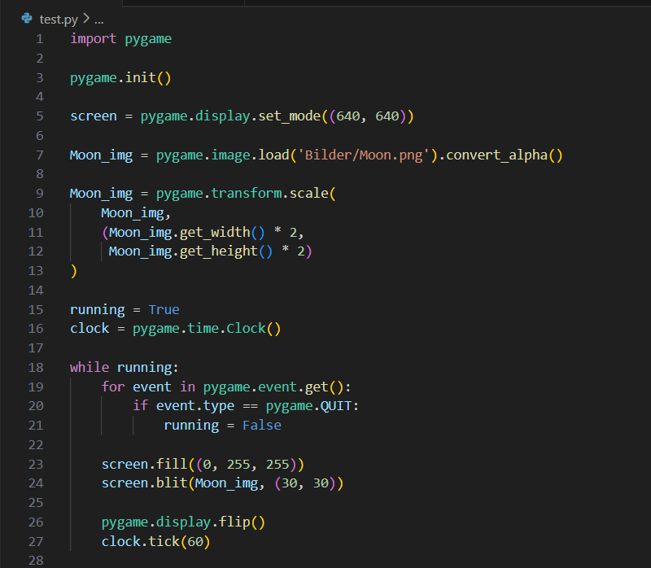

Jeg har skrevet need ideaer på spill og ting man kan lege til spillene
Så har jeg prøvd å få et bilde in i pygame

